Reconfigure The Network To Route Between LANs

In this project we used Cisco Packet Tracer to watch traffic flow between the original setup which had all the switches connected directly to one another and one connection to the router. For this I first checked for any arp requests in the command line using arp /a. If there was, the project wished us to remove them, in which case I would have used arp /d. Then to observe the traffic flow, I sent a ping from Sales 2 to Sales 1, which we could see the packet was broadcasted to each switch and pc as the destination mac address was not inside the arp table of Sales 2. Once the packets IP address matched Sales 1, the arp reply was sent back to Sales 2. This evidently in a large network would create a lot of traffic and potentially slow the system.

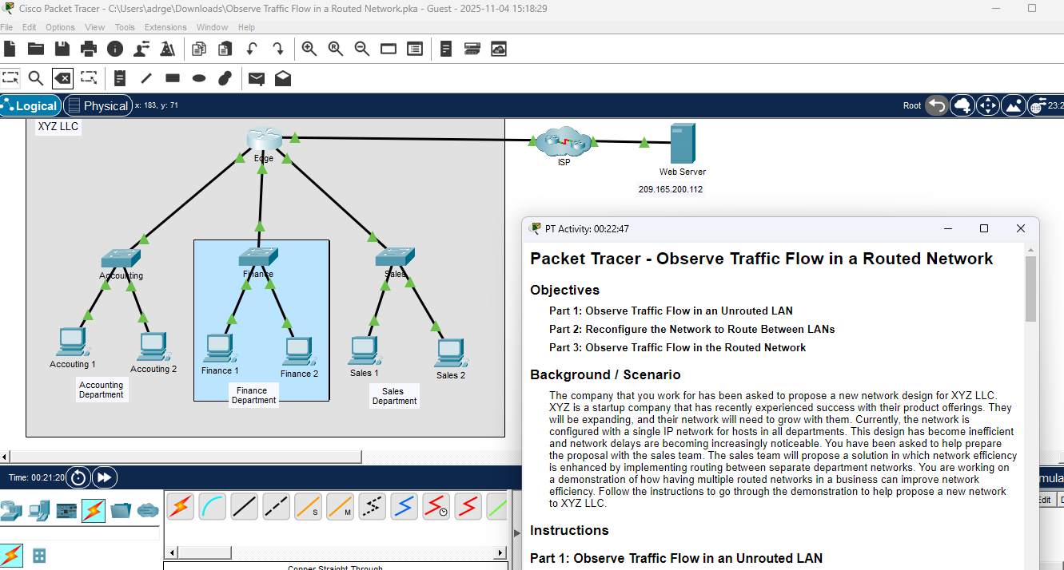
To counter the original setup, the connections between the switches were changed, having a connection per switch to the router, helping to organise each network by team. The traffic flow was observed again between both Sales 1 and Sales 2, this time the packet went straight to Sales 1.

